**Create a user account with the following attributes**:

• username: islam

• Fullname/comment: Islam Askar

• Password: islam

Sudo Useradd -c “islam Askar” islam

Sudo passwd islam

islam

islam



**Create a user account with the following attribute**

• Username: baduser

• Full name/comment: Bad User

• Password: baduser

Sudo Useradd -c “Bad User” baduser

Sudo passwd baduser

baduser

baduser



**Create a supplementary (Secondary) group called pgroup with group ID of 30000**

Sudo groupadd -g 30000 pgroup

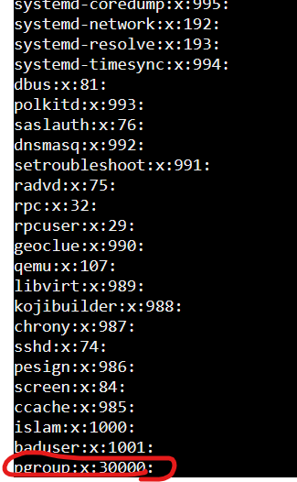

**Create a supplementary group called badgroup**

Sudo groupadd badgroup

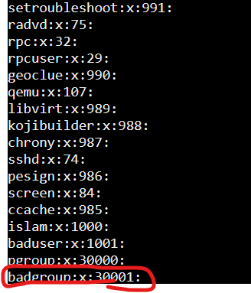

**Add islam user to the pgroup group as a supplementary group**

Sudo usermod -G pgroup islam

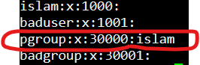

**Modify the password of islam's account to password**

Sudo passwd islam

Password

Password

**Modify islam's account so the password expires after 30 days**

Sudo chage -M 30 islam



**Lock bad user account so he can't log in**

Sudo usermod -L baduser

**Delete bad user account**

Sudo userdel baduser



**Delete the supplementary group called badgroup.**

Sudo groupdel badgroup

